[Go to start of banner](https://confluence.bnymellon.net/display/ISP/RTP+-+Next+Phase+SCOPE" \l "page-banner-start)

[RTP - Next Phase SCOPE](https://confluence.bnymellon.net/display/ISP/RTP+-+Next+Phase+SCOPE)

[Skip to end of metadata](https://confluence.bnymellon.net/display/ISP/RTP+-+Next+Phase+SCOPE#page-metadata-end)

* Created by [Avnish Gupta](https://confluence.bnymellon.net/display/~XBBKR49), last modified by [Mayank Khanna](https://confluence.bnymellon.net/display/~XBBLW8R) on [Jul 19, 2018](https://confluence.bnymellon.net/pages/diffpagesbyversion.action?pageId=107055303&selectedPageVersions=26&selectedPageVersions=27)

[Go to start of metadata](https://confluence.bnymellon.net/display/ISP/RTP+-+Next+Phase+SCOPE#page-metadata-start)

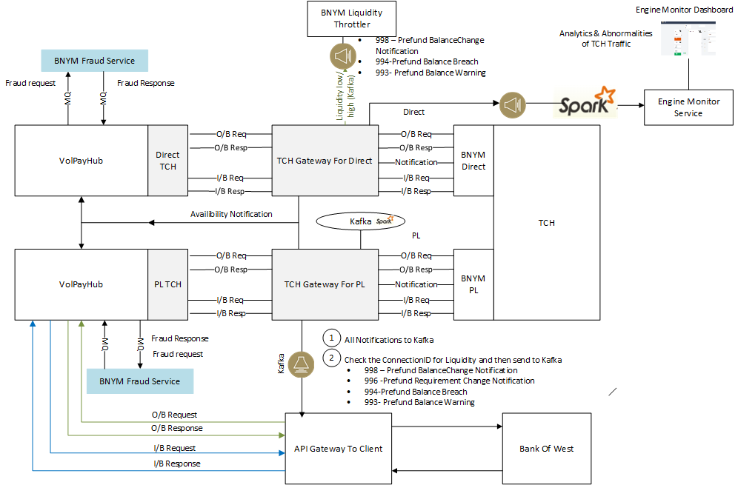

TCH Gateway Details :-

**Work Needing TCH Gateway :-**

* Use same Docker Image Diff Assembly file tagged as new Service to deploy Direct Vs PL specific connectivity.
* Code to look for Either Site 1/2 Or 3/4
* Use the same existing Cache to store site 3/4 status
* Create 2 code for Site 3/4 external side and new queues on the PE side.
* 2 Simulator Needed.
* Use Kafka to send notification to PE,Liquididty and API Gateway.
* TCH Gateway API to accomodate new Participant ID for BOW (to be able to do all functions of TCHSwitch UI (Sign on /off /Echo)
* Swagger Update for TCHSwitch to have a separate swagger URL to control Bank of West like we do today for Direct.

**Fraud Service :-**

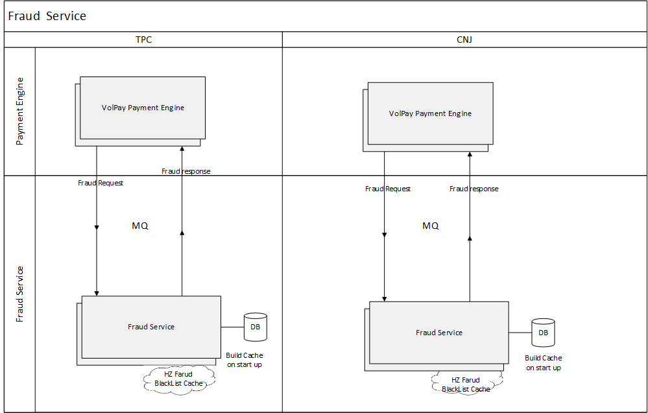

**Work Needed in Fraud :-**

* Spring boot application
* JavaScript Rhino Engine to have if else rules in database
  + sample if(score < 4 and paymentMode ="O/B" and type ="pac008)) "No Hit"
* Datastructure tables to store the Black List.
* HazelCast Mapping of individual Maps 7-8 Maps
* Cache to update when UI updates happen
* Ability to load Cache from UI
* Refresh Cache Weekly
* Pick Request from MQ
* Store Request /Responses in table
* Parse Request
* Match against Black List and Rate Score
* Apply Ruel of hit ,No Hit
* Send Response to MQ
* UI and API- for Black List (Search/Add /Update/Delete)
* OIDC Security Enabling of UI
* UI and API- for Updating Business Rules
* Entitlement (4 eye Process) -- Use Entitlement API to Access to Fraud UI /Amend/ Approve
* UI and API for searching Request / Response

------------------------------------------------------------------------------------------------------------------------------------------------------------------------------------------------------------------------------------------------

TCH Gateway Analytics And Abnormalities of Messages :-

Outbound Messages :-

* Messaghe Status Report (Pacs002)
* Credit Transfer (Pacs008)
* Return Of Funds (Camt.29)
* Request for Information(RFI -Camt026)
* Request For Payament (RFP - Pain013)
* Response to Request for Information (RRFI - camt028)

Inbound Messages :-

* Messaghe Status Report (Pacs002)
* Credit Transfer (Pacs008)
* Return Of Funds (Camt.29)
* Request for Information(RFI -Camt026)
* Response to Request for Information (RRFI - camt028)
* Cancellation(camt.056)

Strainght Analytics :  15 minutes window updating 5 seconds  
-------------------

* Grouping o/b >> Message Type >>Total count >> Total amount >> Top 10 (group by debit a/c number)
* Grouping i/b >> Message Type >>Total count >> Total amount >> Top 10 (group by a/c number)
* Group by i/b >> message type Cancellation(camt.056)>>Check rt:OrgnlInstrId> >>> If count id more than 2 >> Comeup with payload indicating Issue with <head:MmbId / OrgnlInstrId /rgnlEndToEndId>

          ->Multiple cancellation (Potential issue)

Matching Request and Resposne :- 15 minutes window updating 5 seconds  
------------------------------

* o/b -15 minutes window Match (O/b Pacs008 with inbound Pac002 (have referenc for request message type)) call them Accepted if Ids Match
* i/b - 15 minutes window match(i/b Pacs008 with outbound Pacs02 (have referenc for request message type)) call them Accepted if Ids Match call them ?( Wait for confirmation) . Also match with
* Need to publish JSON payload to kafka so can be shown by graph.
* Engine Monitor API will consume kafka and store last 4 hours of above stats in local cache
* Engine Monitor UI will poll this API every 5 seconds update graphs.
* API to call TCHSwitch Details of transactino is sought for the give time frame
* Typical Payload for Kafka ?? Keep Header (From/To)- DateTime window --> and Above Info

Below ARE JUST NOTES.

Some Notes on work Needed :-

**RPX API :-**

* Engine Monitoring API for Monitoring UI -----2
* API for TCHGateway for PL Operational UI -----1
* API for Throttelr for PL Operational UI ------1

**Engine Monitor :-**

* Monitor Routes from the RouteRegistry table.
* Monitor Service from the Service Registry table.
* Membership Upload file monitoring.

**24/7 Changes Interim:- No Changes in DB are targeted    - PRIORITY 2 AFTER BUSINESS ENHANCEMENTS ARE DONE FOR PRIVATE LABEL**

* Rearchitecture of VolPay and Interfaces
* Infrastructure : - MQ (separting) ,ReArchitect apps , Certificate (MQ and Application)
* VolPay Changes
  + Defalut Routes to be Off on start up .
  + Isolation of Service Registry and Route Registry to capture zones in the table TPC-1/CNJ-1/TPC-2/CNJ2 . During smoke test need a way to pass API traffic in Isolated zone only.
  + Separate NAS for zone pair
  + TO be able to call API to put in VolPay components Listener Off ,NAS listener Off.
  + Smoke Test - Silver Bullet Message in zone pair which got deployed (special Key work end-to-end-id) which doesn't go to interfaces but logges in DB.
* Throttler ReFactor - MQ PAths , API to expose for UI
* TCH Gateway Refactor
* TCHGateway PL
* OSA Refactor
* FCS Refactor (CFC Impact)
* BEX Refactor
* POC with BXP3 API to be able to use form UI for Deploy ,F-5 control etc.
* Automated Deployment UI- Integrate above APIs , BXP3 API
* API for Deployment.
* Using BXP -CLI to deploy
* Using BXP -CLI to F-5 off

**TCH Gateway :  - Priority 1**

* TCH Simulator - Separate instance for simulator
* New instance
* Retry logic for communication with Payament Engine
* Turning on /off membership (Particpant Connectino ID) via VolPay
* Notification implementation for Direct Clients (12-13 JIRAs)
* Notification implementation for PL Clients (12-13 JIRAs).

RTP MQ Form  
RTP MQ Digital Certificate Form  
RTP Application Digital Certificate Form  
RTP Host Configuration Form - Network  
RTP Reporting Connect Direct Form  
RTP Connect Direct Digital Certificate Form   
RTP Client Information Form (customer submits)

**Throttler :-**

* While doing Adjeustement to be able to clear Pending Transaction.
* Liq zero change tobe handle .
* Exception handling in Throttler.

**VolPay Changes for PL :-**

* Non Fucntional JIRAs (See the excel Girisha)
* Calling Client API ,
* Fraud
* Fraud alert messages to be passed through to BotW (and vice versa)

**BNYM Fraud Service :** PRIORITY 1 ,Requirements are not firmed up

**Data Encryption by end of 2018**  
**Database Archival**   
**BXP3 Migration :** Break Down by VOlPay and Internal interfaces migration

-----------------------------------------------------------------------------------------------------------------------------------------------

Sprint 5- 2.7.7 - July 15 to 31 Sep  
Sprint 6- 2.7.8 - 1 Oct to Nov 30  
Sprint 7- 2.7.9 - Oct 15 to Dec 31